Mobile Network Penetration and Trends of Usage of Smartphones in Sri Lanka

Accidents can happen anywhere inside this Small Island, it can be a remote location or an urban location. Because of that it is very important study the mobile network penetration inside Sri Lanka. Not only that it is of pivotal importance to study the level of mobile literacy of Sri Lankans to determine whether the insurance filed agents will be comfortable in using such smartphone based solution.

There has being a significant increase in the mobile subscriptions in Sri Lanka over the last decade. It is stated in tradingeconomics (2014) that in the year 2008 up to 95% of population is covered by mobile cellular network in Sri Lanka. The following chart extracted from Trading Economics website illustrate the increase of mobile subscription in Sri Lanka from 2001 to 2013.

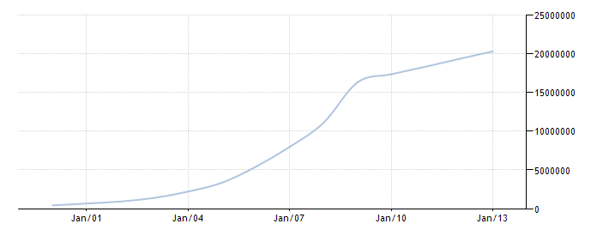

It is clear that Sri Lanka enjoys a high mobile literacy and considering the statistics of last ten years it is evident that emerging market trends in the mobile usage are seen in Sri Lanka. Apart from that, in Sri Lanka there are approximately over 4 million internet users. According to Nielsen’s “2013 Sri Lanka review” report further emphasizes this trend which highlights 57% of the internet users in Sri Lanka do access internet through a mobile device.

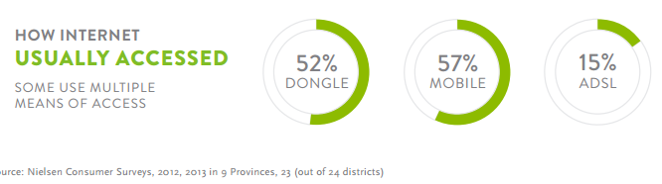

In the present scenario there are five mobile network operators in Sri Lanka namely Dialog, Mobitel, Etisalat, Hutch and Airtel which provides mobile connections to consumers. Dialog offers a wide coverage and undisturbed service whereas Mobitel also have good coverage and specially a good 3G coverage. However if you are not traveling frequently Etisalat or Airtel would be good options. They offer lower call rates. Some youths opt to Hutch as they can easily obtain a connection and easily switch for a new one.

When considering the mobile network coverage available in Sri Lanka, it was obvious to researcher that Sri Lanka enjoys an Island wide mobile coverage encompassing almost 4/5th of the Island. This coverage is facilitated through different network types such as, CDMA, WCDMA, HSDPA, 3G, GSM, and GPRS mostly. Along with that 4G networks are also starting to emerge near major cities. Hence, this tendency to move ahead with latest next generation networks and the breadth of coverage testifies to the existence of positive trends in terms of mobile technological usage. The following figures shows the network coverage of two major service providers.

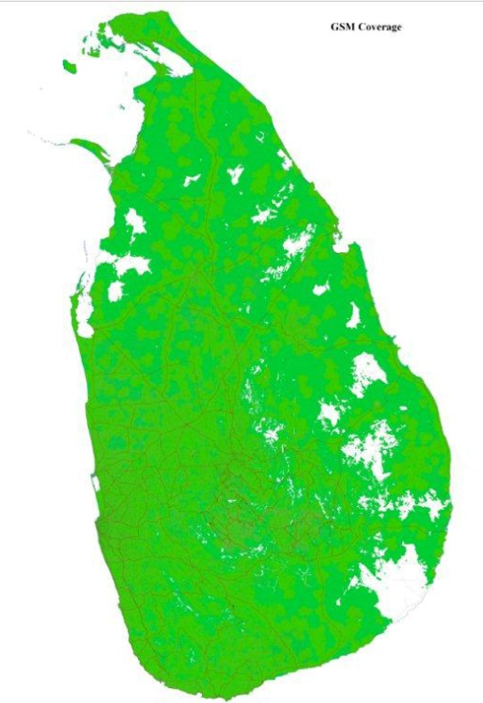 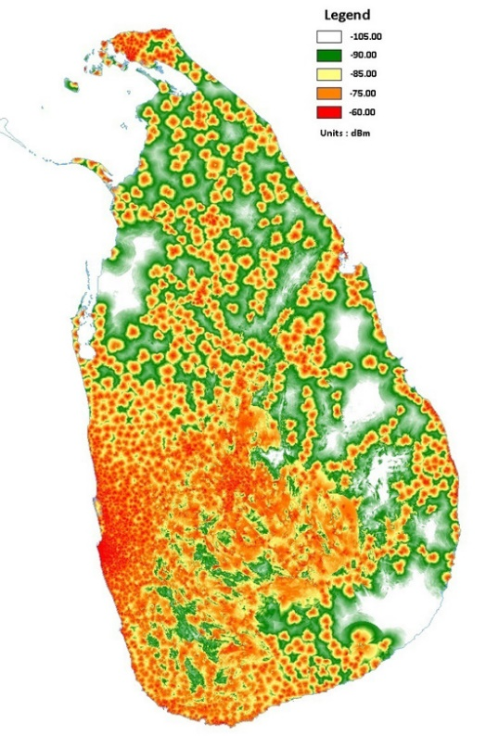

Although mobile and internet usage is widespread in the country it is also important to take a look at the usage of smartphones also. Couple of years back smartphones were not much popular on the market since they were perceived as high end devices which are considered to be expensive also. But now it’s not the case it has become widely affordable and available across the island, you can buy a decent smart phone for a very reasonable price. This results in more people buying smartphones and more people using internet through their device.

By taking into consideration the above facts it is evident that mobile literacy in Sri Lankans is in a healthy condition and all the indications are towards positive growth. . Moreover, expanded and expanding nature of mobile network coverage in Sri Lanka shows the emerging trends in mobile technologies and services. Hence, it can be said that Sri Lanka is in the threshold of an adorning mobile era which would facilitates life styles and cooperate habits shaped by mobile technologies.

References

Trading Economics 2014, *Mobile cellular subscriptions in Sri Lanka*, Viewed 29th November 2014

<http://www.tradingeconomics.com/sri-lanka/mobile-cellular-subscriptions-wb-data.html>

Iqbal I. 2014*, Rapid Growth of Mobile Internet Usage in Sri Lanka,* Viewed 25th November 2014

<http://infasiqbal.com/rapid-growth-of-mobile-internet-usage-in-sri-lanka/>

Mobitel 2104, *Mobitel GSM and 3G Coverage,* Viewed 26th November 2014

<http://www.mobitel.lk/images/English/common/Srilanka_GSM_Coverage%2030112013.jpg>

Dialog Axiata 2014, *Coverage Map,* Viewed 26th November 2014

http://www.dialog.lk/support/mobile/coverage-service-points/coverage-map/